CONTENTS
1 INTRODUCTION 1
1.1 Organization Profile 1
1.2 Project Overview 4
1.3 Problem Statement 6
2 LITERATURE SURVEY 7
2.1 Overview of Software Used 7
3 REQUIREMENT SPECIFICATIONS & ANALYSIS 22
3.1 Project Description 22
3.2 Feasibility Study 36
3.3 Requirement Analysis 38
4 DESIGN 44
4.1 Data Flow Diagrams: 44
4.2 Data Dictionary 50
4.3 E.R Diagram 51
5 Implementation 52
5.1 Coding 52
6 TESTING 63
6.1 System Testing 63
7 RESULTS 67
8 CONCLUSION 75
8.1 Future Enhancement 76
BIBLIOGRAPHY 82

INTRODUCTION

Organization Profile

Soon after the attainment of independence to India, a body called Defence Science Organization was established in 1948 for the developments of Defence and Science. In 1958 a major re-organization was implemented by which the present DRDO (Defence Research & Development Organization) was formed. Amalgamating the Defence Science Organization with some of the existing technical development establishments formed this DRDO.

This organization from then continued to prove science-based improvements to weapons and equipments until late sixties. The mission of this organization was then broadened to improve design and development of weapon and equipment, in addition to providing scientific assistance to the Defence services .In the Seventies, DRDO entered into a development programme of initial weapon system/equipment and got through successfully.

To facilitate better administrative efficiency in sanctioning and managing complex technological problem in Defence R&D Projects, a separate Department of Defence Research &Development was formed in 1980,which at present administrators both the Defence R&D Organization and the Aeronautical Development Agency.

DRDO has gone through a phased program built up of infrastructures and expansion of various fields of Defence Science & Technology. Now the number of laboratories and small cells attached to DRDO cover practically all the Scientific and technological disciples of defence interest. Among these laboratories DLRL is one of the major laboratories.
Role of DLRL

As a supporting Organization for Armed Forces, the main functions of DLRL and the other such Labs are as follows:

- Design and develop Weapons and Equipments based on the operational requirements as defined by the Services and help in their indigenous production.
- To render scientific advice to the Services and their Head Quarters.
- To carry out basic and applied research to solve the problems of the Services.
- To evaluate and conduct the technical trails of new weapons and equipment which are designed and developed in the country under DRDO.

DLRL plays a vital role in technical development for national security. DLRL is one of the biggest labs in the country under DRDO. The whole infrastructure of DLRL consists of large Scientific and Technical manpower, sophisticated equipments and modern computer systems with the state-of--art technology and which are being utilized whenever the need was felt for producing high performance

Software Quality Assurance Group (SQAG)

Software Quality Assurance Group of DLRL is primarily responsible for the quality assurance of the software developed for the weapon system. Functionality responsibility of this Directorate can be classified as follows:

Verification And Validation

This Group performs the verification and validation of the following software functions:
- To carry out review at various phases during development.
- Performing static analysis of the received data.
- Carry out the validation work as per the defined process.
- Identification of appropriate testing techniques and analysis.
- Documentation and presentation of the observations.

Software process and Standards

The responsibilities of this group are:

- Familiarization and study of various software standards like IEEE, DOD, ISO etc, is an application for soft ware development and quality assurance.

- Evolving coding standards for different programming languages. Preparation of checklist to be observed during review at the end of the phase of software life cycle.

Project Overview

With the introduction of the Computer Networks, the need for automated tools for accessing and sharing data and other information (typically databases) stored on other computer became evident. An application is designed to access databases of any computer in a network. Such databases are called Distributed Databases.

A distributed database is a set of databases stored on multiple computers that typically appears to applications as a single database. Consequently, an application can simultaneously access and modify the data in several databases in a network.

The project “Remote Database Access” aims at retrieving remote databases residing in either Windows(Oracle) or Solaris(Sybase).The retrieved databases are used to Create, Read, Update and Delete(CRUD) data in the tables. The project is developed on Windows NT workstation with VC++ as front-end and Oracle 8.0.3 and Sybase as Back-end.

A process is written in the remote system, which updates its database, which is reflected in its copy in the local system. Queries always return the data in the local system. Any updates on the copy of remote database will not be reflected in the original remote database.

The local system consists of a collection of databases including its own local database and a copy of each remote database. In the local System, an interface is developed in VC++ with appropriate controls to access databases located in remote systems. The interface also provides opacity to the user about the under-lying Operating system in the remote system being accessed where the database being Oracle in WINDOWS. The interface is capable of accepting an SQL Query and provides the output tables to the user.

A VC++ process is written each remote system, which provides an interface to the user to update data in that database.

Coding is done using SQL to handle reflection of the updated fields in the (remote) database into its copy in the local system.

The concept of Basic Read-Only Replication is used to develop the project. Most commonly, replication is useful to improve the performance and protect the availability of applications, because alternate data access options exist. For example, an application might normally access a local database rather than a remote server to minimize network traffic and achieve maximum performance.

Problem Statement

As Technology is improving day-by-day people and places no more feel the distance between each other. Communication has become very easy, with the advent and rapid enhancements of Computer Networks.

Indian Defence is a vast organization ranging all over the country. It has huge amounts of data to be stored belonging to various departments all over the country. Their databases are to be shared among many organizations throughout the country located anywhere in the country, safely and securely.

For this purpose Computer Networks play a vital role allowing people to access Remote Databases. While using Computer Networks is very helpful, it has a few implications, such as, Network Congestion and failure of Network Servers, which may lead to loss of valuable information and many security risks.

To reduce Network congestion and failures of Network servers due to excess traffic flow, the application Remote Database Access uses a technique to overcome the above specified problem.

This application Remote Database Access duplicates the databases of required remote databases into its own local storage. It then accesses the copy of remote databases from its local storage. Hence, reducing, in fact, removing all the traffic from itself to the remote system in the network.

If any changes occur in the remote databases, they are reflected on to the respective copies in the RDA system. Thus, keeping the user up to date with the changes.

This is a considerable solution to above specified real time problems.

LITERATURE SURVEY

2.1 Overview of Software Used

Visual C++

Microsoft Visual C++ 6.0 is member of the visual studio 6.0 family for development products Visual C++ (VC++) Provides an Integrated Development Environment (IDE) that allows us to write, build and debug 32Bit C/C++ Programs. It also provides easy navigation of the source code.

Visual C++ AppWizards:

VC++ provides a set of AppWizards (application Wizards) that guide you through creating a new program. These AppWizards provide some basic setting’s and/or code, thereby saving considerable time .it is important to select the appropriate AppWizard for the type of application you want to create.

Console Vs Windows Projects:

A console program is meant to run under the Ms-Dos connected prompt it’s a 32-bit program but not a windows program. The first function that is called in C/C++ console-based program is:

int main (int argc, char *argv [])

The first function that is called in a windows-based program is:

int WINAPI WinMain(HINSTANCE hInstance, HINSTANCE PrevInstance,LPSTR lpCmdLine,int nCmdShow)

A console application doesn’t present a user interface, such as dialog.

Workspace and projects:

VC++ organizes programs that were created using the AppWizards as groups of projects in a workspace. That is a workspace consists of projects, and individual projects contain files. Projects can share files.

The Visual C++ ODBC Classes
When a database program is created with Visual C++'s AppWizard, we end up with an application that draws extensively on the various ODBC classes that have been incorporated into MFC. The most important of these classes are CDatabase, CRecordset, and CRecordView.
AppWizard automatically generates the code needed to create an object of the CDatabase class. This object represents the connection between your application and the data source that you will be accessing. In most cases, using the CDatabase class in an AppWizard-generated program is transparent to you, the programmer. All the details are handled by the framework.
AppWizard also generates the code needed to create a CRecordset object for the application. The CRecordset object represents the actual data currently selected from the data source, and its member functions manipulate the data from the database.
Finally, the CRecordView object in your database program takes the place of the normal view window you're accustomed to using in AppWizard-generated applications. A CRecordView window is like a dialog box that's being used as the application's display. This dialog box-type of window retains a connection to the application's CRecordset object, hustling data back and forth between the program, the window's controls, and the recordset. When you first create a new database application with AppWizard, it's up to you to add edit controls to the CRecordView window. These edit controls must be bound to the database fields they represent so that the application framework knows where to display the data you want to view.
ODBC Open Data Base Connection:

Open Data Base Connection is a windows technology that lets a database client application connect to the external database. To use ODBC, the database vendor must provide an ODBC driver for the data access. Once this driver is available, the client machine should be configured with this driver. The destination of the database, login id and password is also to be configured on every client machine. This is called as a Data Source. The user can configure multiple data sources with same or different drivers on the same machine. Thus using ODBC, it is possible to access heterogeneous data from any client. The open Database connectivity architecture.

Data
Base
Client
Application
ODBC
Driver
ODBC Data
Source
ODBC Driver
Manager

Creating on ODBC data source:

Before any application can access an ODBC database, the ODBC drivers must be installed and a Data Source Name (DSN) creates using the control panel. The DSN is used whenever a reference is made to an ODBC database.

Sequences of steps have to be under taken to set up an oracle database:

- Double click on ODBC configuration option under control panel
- A list of ODBC data sources is displayed.
- Create new data source using ODBC driver for oracle.
- Select Add button to add new ODBC data source. Lists of ODBC drivers that are currently installed in the system are displayed. Select the ODBC driver for the oracle.

Features of Oracle :

Salient Features of ORACLE

Oracle is a Comprehensive Operating Environment that packs the power of a Mainframe relational Database Management System into users Microcomputer. It provides a set of functional programs that user can use, as Tools to build structures and perform tasks, because applications developed in Oracle are completely portable to other versions. The programmer can create complex applications in a single service environment and then move it to a Multi-user platform. User do not have to an expert to appreciate oracle but the better user understand the program, the productively and creatively he can use the tools it provide.

Key Features:

Operating within the frame work if network computing Architecture (NCA), Oracle8 provides:
- Maximum performance and scalability through its unique design with the Windows NT multi threaded architecture. In addition,Oracle8 for windows NT has been optimized to take full advantage of windows NT’s multi-tasking
- Integration with the performance monitor, event viewer, Registry and security login.
- Automatic authentication of users by the Windows NT operating system.
- Central, easy-to-use graphical user interface (GUI) distributed database management.
- Using Oracle Enterprise manager

ORACLE is Portable

The ORACLE RDMS is available on a variety of platforms ranging from a PC to super computers and as a multi-user NetWare Laudable Module (NLM) for NOVEL-NETWARE, ORACLE software is ported to work under different operating systems and is the same on all systems. Applications developed in ORACLE can be ported to any operating system with a little or no modification.

ORACLE is Compatible

ORACLE software is compatible with industry standards. ORACLE supports open database connectivity (ODBC). ORACLE commands can be used for communicating with IBM-DB2 Mainframe RDBMS or any other RDBMS which supports ODBC.

ORACLE supports Client-Server Computing

For computing environment that are connected via networks, ORACLE combines the data physically located on different computers into one logical database that can be accessed by all network users.

ORACLE Supports the Following Codd Rules

Rule 1: Information Rule (Representation of information) - YES
Rule 2: Guaranteed Access - YES
Rule 3: Systematic Representation of missing information - YES
Rule 4: Comprehensive On-line Catalogue - YES
Rule 5: Comprehensive Data Sub Language - YES
Rule 6: View Updating - PARTIAL
Rule 7: High level Insert, Update, Delete - YES
Rule 8: Physical Data Independence - PARTIAL
Rule 9: Logical Data Independence - PARTIAL
Rule 10: Integrity Independence - YES
Rule 11: Distributed Independence - YES
Rule 12: Non-Subversion - YES
Features of ORACLE

- Client/Server architecture

- Data Independence

- Ensuring data integrity and data security

- Managing data concurrency

- Parallel processing support to speed up data entry and

- On-line transaction processing used applications dB procedures, functions and packages.

ORACLE Tools

ORACLE Tools do 4 Major Kinds of work

1. Database Management.

2. Data Access and Manipulation.

3. Programming.

4. Connectivity.

ORACLE Data Browser

This is a graphical interactive data access tool. You can use Browser's graphical user interface to built and send adhoc queries to ORACLE Database.

SQL *Plus

It is a direct to the Oracle RDBMS. You can use SQL commands to define, control, manipulate, and Query data.

ORACLE Forms

It supports applications in bit mapped graphical user interfaces like Windows. It provides a convenient and easy method for non-experts to query a database and update, delete or add information. Oracle's forms driven query by example approach is a boon for users not familiar with SQL language.

ORACLE Reports

SQL * REPORT WRITER is a menu driven Formatting tool which uses non-procedural SQL to create Professional looking Reports.

ORACLE Menu

It is an advanced, non-procedural tool for integrating different ORACLE functions and Forms into menu-driven system.

SQL

The name stands for Structured Query Language. it is a data access language, which communicates with the database manager.

SQL Processing Capabilities

This can be used to the conceptual schema and also give some details about how to implement this schema in the physical devices used to store data. The definitions include all the entity sets and their associated attributes as well as the relationship among the entity sets.

ORACLE is RDBMS, which stores and displays data in the form of tables. A table consists of Rows and Columns; a single row is called a record. ORACLE is Modular System that contains Oracle database (dBMANAGER) and several tools functional programs.

Relational Database Management System:

A Relational Database Management System (RDBMS) can perform a wide range of tasks .It acts as a transparent interface between the physical storage and the logical presentation of data .it provide a set of more or less flexible and sophisticated tool for handling information.
User can use the tools:

- Define a Database

- Query the Database

- Add, Edit and Delete data

- Modify the structure of Database

- Communicate with in the Network

- Export and Import the data

Security

Because it gives so much control over data, a relational DBMS can also serve as foundation from products that generate applications and extra data. E.F Codd has formulated 12 rules for RDMS in 1970.In addition to rules, there exists a rule called rule zero, which states:

“A relational system must be able to manage databases entirely through its relational capabilities. Any DBMS that advises users to some no-relational methods to achieve acceptable performance should be interpreted as an apology by vendor”.

The Twelve Codd Rules are as Follows:

- Information Rule

- Guaranteed access : All data must be accessible with no ambiguity. This rule is essentially a restatement of the fundamental requirement for primary keys. It says that every individual scalar value in the database must be logically addressable by specifying the name of the containing table, the name of the containing column and the primary key value of the containing row.

- Systematic treatment of null values : The DBMS must allow each field to remain null (or empty). Specifically, it must support a representation of "missing information and inapplicable information" that is systematic, distinct from all regular values (for example, "distinct from zero or any other number," in the case of numeric values), and independent of data type. It is also implied that such representations must be manipulated by the DBMS in a systematic way(Oracle does not support this rule)

- Active online catalog based on the relational model : The system must support an online, inline, relational catalog that is accessible to authorized users by means of their regular query language. That is, users must be able to access the database's structure (catalog) using the same query language that they use to access the database's data.

- The comprehensive data sublanguage rule:

The system must support at least one relational language that :

(a) Has a linear syntax,
(b) Can be used both interactively and within application programs,
(c) Supports data definition operations (including view definitions), data manipulation operations (update as well as retrieval), security and integrity constraints, and transaction management operations (begin, commit, and rollback).

- The view updating rule:
All views that are theoretically updatable must be updatable by the system.

- High-level insert, update, and delete:
The system must support set-at-a-time insert, update, and delete operators.

- Physical data independence:
The physical representation of the data must be invisible to the user, so that the user can manage the data according to need rather than according to the way it is stored.

- Logical data independence:
If a user's view of the data has been defined, then changing the logical structure of the data (tables, columns, rows, and so on) must not change the user's view.

- Integrity independence:

Integrity constraints must be specified separately from application programs and stored in the catalog. It must be possible to change such constraints as and when appropriate without unnecessarily affecting existing applications.

- Distribution independence:

The distribution of portions of the database to various locations should be invisible to users of the database. Existing applications should continue to operate successfully:

(a) When a distributed version of the DBMS is first introduced; and
(b) When existing distributed data are redistributed around the system.

- The Non-subversion rule:

If the system provides a low-level (record-at-a-time) interface, then that interface cannot be used to subvert the system, for example, bypassing a relational security or integrity constraint.

Oracle the Right Tool

Why Choose ORACLE?

To keep track of records is often the best reason to consider buying a software package. Choosing a proven product increase the chance that we will get a system capable of meeting all our needs.

ORACLE has had many years in the relational market of often on the large, complex application. Although Oracle demands greater expertise on the part of the application developed oracle will be able keep pace with growth and change in the world large.

(a) Oracle gives you Security and Control:

Oracle has several features that ensure the integrity of the database. if an interruption occurs in processing, a Rollback can reset the database to a point before the disaster .If a restore is necessary, Oracle has a Roll forward command for recreating your Database to its mast resent save point.

Oracle provide user with several functions for securing data. Grant and Revoke commands limit access to information down to the row and column level. Views are valuable feature for limiting access to the primary tables in the database.

(b) The Oracle Environment:

Oracle is a modular system that consists of the Oracle database and several functional programs. Oracle’s tools do four major things of work. Database Management Data access and Manipulation Programming Connectivity

(c) Oracle Performs Competitively:

Oracle has been constantly improved to perform competitively on the larger database. Because relational database systems have been hampered by a reputation for low access times, Oracle has had to prove itself continually. Oracle unique clustering techniques for storing data on the disk are another performance again.

Additional functions help control complex database installations, the active data dictionary, which automatically updates and logs modification to the database, provides documentation. Database table, partition and space altering “on the fly eliminates cumbersome data off loading and unloading from the modification process.

Finally, Oracle stores the DBMS kernel in extended memory, so more main memories are available for other applications.

(d) Oracle Supports Application Development:

SQL forms are an excellent user-friendly tool for quickly creating forms. User can start with externally simple default forms or use the full screen painting function to create detailed screens or accessing and updating multiple tables and for controlling and editing data as it is entered.

Forms provide unique control devices called triggers to influence user action on field before, during and after data input. Forms commands or external procedural language subroutines form within a form SQL * Forms is a an advanced fourth generation tool that will adopt to your requirements extremely well by adapting the intend operations.

The menus given by Forms can link all of our forms, programs and queries in and easily maintained secure MENU structures.

All of Oracle data access manipulation tools are firmly based on ANSI standard SQL. In Oracle, the tools that user will use to access and manipulate data, as well as to design or user applications. Each provides a separate point of entry and a unique database with SQL COMMANDS, FORMS offers a user-friendly way to create and user forms.

SQL * Report writer lets you to create formatted output Oracle Graphics gives pictorial representation of data form accurate making.

Structure of Oracle Database:

Oracle database can be described at two different levels

- Physical Structure
- Logical Structure

Physical Structure:

- Two or more log files
- One control file

Logical Structure:

- Table space
- Segments
- Extents
- Data Blocks

The data files contain all user data in terms of tables, indexes and views. The log file contains the information to open and be recovered, of Undone after a transaction.

The controls file physical data, media information to open and manage the data files. If the control file is damaged the server will not be able to open and use the database. Even if the database undamaged.
Data translation:

Data is translated through a set of DLLs specific to Seagate crystal report. The program uses the DLLs specific to a certain data type to understand how data is organized for that type and to present it correctly when your report is printed, previewed, or exported.

SQL is the de facto standard language used to manipulate and retrieve data from these relational databases. SQL enables a programmer or database administrator to do the following:

Modify a databases structure, change system security setting, add user permission on databases or tables, query a database for information, update the contents of database.

Data Manipulation Language (DML)

The language used to manipulate data in the database is called Data Manipulation Language (DML). This involves of data into the database, and deletion or modification of existing data. The first of these data manipulation operations is called a query. The DML can be procedural. The user indicates not only what to retrieves but how to go about retrieving it.

Data Control Language (DCL)

These commands are used to control usage and access of data. The most commonly used one does include Grant, Revoke.

Connectivity Tools:

Connectivity tools make Oracle available to network and to other database managers. SQL star is group of products include SQL * NET* which is responsible for transforming the command into TCP/IP packets for sending to server for parsing of the SQL commands and again do the same at the time of receiving the desired result form the backend , i.e. server.

ODBC is a tool which helps in connecting to variety of servers such as SYSBASE, INFORMIX and INGRESS etc.

REQUIREMENT SPECIFICATIONS & ANALYSIS

Project Description

The project “Remote Database Access” aims at retrieving remote databases residing in either Windows (Oracle) .The retrieved databases are used to Create, Read, and Update and Delete (CRUD) data in the tables. The project is developed on Windows NT workstation with VC++ as front-end and Oracle8 (Enterprise Edition).
A process is written in the remote system, which updates its database, which is reflected in its copy in the local system. Queries always return the data in the local system. Any updates on the copy of remote database will not be reflected in the original remote database.

The local system consists of a collection of databases including its own local database and a copy of each remote database. In the local System, an interface is developed in VC++ with appropriate controls to access databases located in remote systems. The interface also provides opacity to the user about the under-lying Operating system in the remote system being accessed where the database being Oracle in WINDOWS. The interface is capable of accepting an SQL Query and provides the output tables to the user.
A VC++ process is written each remote system, which provides an interface to the user to update data in that database.
Pictorial View of implementation of Remote Database Application can represented by following diagrams

Remote
Database
Application

Local
System

Remote
System(s) (Remote Database)
Database
(Local)

Once the application is started, it duplicates all the required remote databases into its local storage.

Remote
Database
Application
(Started)

Local
System

Remote
System-4 (Remote Database)
RDB4
Databases
(Local)
RDB1
RDB2
RDB3
Remote
System-2 (Remote Database)
RDB2

Remote
System-1 (Remote Database)
RDB1

Remote
System-3 (Remote Database)
RDB3

Copies of the remote databases are made into the local system by the application as soon as the application starts.

If any changes occur in databases at the remote sites, those changes are immediately reflected onto their respective copies at the local system.

Remote
System-1 (Remote Database)
RDB1 (changed)

Remote
Database
Application
(running)

Local
System

Remote
System-4 (Remote Database)
RDB4

Remote
System-3 (Remote Database)
RDB3 (changed)
Remote
System-2 (Remote Database)
RDB2

Changes
Reflected
Databases
(Local)
RDB1(changed)
RDB2 RDB4(Changed)

If any changes are made to the copy of remote database, those changes are not reflected onto the original remote database.

Remote
Database
Application
(running)

Local
System

Remote
System-4 (Remote Database)
RDB4
Databases
(Local)
RDB1 RDB2(changed)
RDB3(changed)
RDB4

Remote
System-3 (Remote Database)
RDB3
Remote
System-2 (Remote Database)
RDB2

Remote
System-1 (Remote Database)
RDB1

Thus the application Remote Database Access accesses remote databases but modifies them locally and it cannot update these changes onto the original remote databases.

The above Diagrams illustrate the complete project.

Coding is done using SQL to handle reflection of the updated fields in the (remote) database into its copy in the local system.

The concept of Basic Read-Only Replication is used to develop the project. Most commonly, replication is useful to improve the performance and protect the availability of applications, because alternate data access options exist.

What Is Replication?
Replication is the process of copying and maintaining schema objects in multiple databases that make up a distributed database system. Replication can improve the performance and protect the availability of applications because alternate data access options exist. For example, an application can normally access a local database rather than a remote server to minimize network traffic and achieve the best performance. Furthermore, the application can continue to function if the local server fails while other servers with replicated data remain accessible. Oracle supports two forms of replication: basic and advanced replication.

Basic Replication
With basic replication, data replicas provide read-only access to the table data that originates from a primary or "master" site. Applications can query data from local data replicas to avoid network access regardless of network availability. However, applications throughout the system must access data at the primary site when updates are necessary. Figure 1-1 illustrates basic replication.

Figure 1-1 Basic, Read-Only Replication

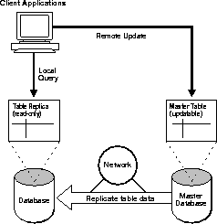

Oracle Server can support basic, read-only replication environments using read-only table snapshots.

Basic Replication Concepts
Basic replication environments support applications requiring read-only access to table data originating from a primary site. The following sections explain the fundamental concepts of basic replication environments.

Uses of Basic Replication
Basic, read-only data replication is useful for several types of applications as discussed under the following headings.

Information Distribution
Basic replication is useful for information distribution. For example, consider the operations of a large consumer department store chain. In this case, it is critical to ensure that product price information is always available and relatively current and consistent at retail outlets. To achieve these goals, each retail store can have its own copy of product price data that it refreshes nightly from a primary price table.

Figure 1-3 Information Distribution
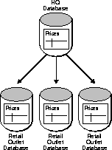

Information Off-Loading
Basic replication is useful as a way to replicate entire databases or off-load information. For example, when the performance of high-volume transaction processing systems is critical, it can be advantageous to maintain a duplicate database to isolate the demanding queries of decision support applications.

Figure 1-4 Information Off-Loading
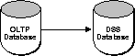

Information Transport
Basic replication can be useful as an information transport mechanism. For example, basic replication can periodically move data from a production transaction processing database to a data warehouse.

Read-Only Table Snapshots
A read-only table snapshot is a local copy of table data originating from one or more remote master tables. An application can query the data in a read-only table snapshot, but cannot insert, update, or delete rows in the snapshot. Figure 1-5 and the sections that follow explain more about read-only table snapshots and basic replication.

Figure 1-5 Basic Replication Components: read-only snapshots, master tables, and snapshot logs
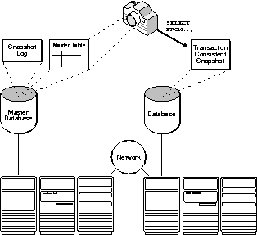

Read-Only Snapshot Architecture
Oracle supports basic data replication with its table snapshot mechanism. The following sections explain the architecture of simple read-only table snapshots.

A Snapshot's Defining Query
The logical data structure of table snapshots is defined by a query that references data in one or more remote master tables. A snapshot's defining query determines what data the snapshot will contain.
A snapshot's defining query should be such that each row in the snapshot corresponds directly to a row or a part of a row in a single master table. Specifically, the defining query of a snapshot should not contain a distinct or aggregate function, a GROUP BY or CONNECT BY clause, join, restricted types of sub-queries, or a set operation. The following example shows a simple table snapshot definition.
CREATE SNAPSHOT sales.customers AS
SELECT * FROM sales.customers@hq.acme.com
Note: In all cases, the defining query of the snapshot must reference all of the primary key columns in the master table.
A snapshot's defining query can include restricted types of sub-queries that reference multiple tables to filter rows from the snapshot's master table. A sub-query snapshot can be used to create snapshots that "walk up" the many-to-one references from child to parent tables that may involve multiple levels. The following example creates a simple sub-query snapshot.
CREATE SNAPSHOT sales.orders AS
SELECT * FROM sales.orders@hq.acme.com o
WHERE EXISTS
(SELECT c_id FROM sales.customers@hq.acme.com c
WHERE o.c_id = c.c_id AND zip = 19555);

Internal Snapshot Objects
When you create a new, read-only table snapshot, Oracle creates several underlying database objects to support the snapshot.
- Oracle always creates a base table to store snapshot data. The name of a snapshot's base table is SNAP$_snapshotname.
- Oracle creates an index for the primary key in the snapshot base table. The name of the index is the name of the index used to enforce the corresponding PRIMARY KEY constraint at the master site.
- Oracle always creates a view for each snapshot. The view takes the name of the snapshot and provides read-only access to the snapshot.
- Oracle might create additional indexes for a snapshot defined with a sub-query.

Snapshot Refreshes
A snapshot's data does not necessarily match the current data of its master tables. A table snapshot is a transaction-consistent reflection of its master data as that data existed at a specific point in time. To keep a snapshot's data relatively current with the data of its master, Oracle periodically refreshes the snapshot. A snapshot refresh is an efficient batch operation that makes that snapshot reflect a more current state of its master.
You must decide how and when to refresh each snapshot to make it a more current. For example, snapshots stemming from master tables that applications often update usually require frequent refreshes. In contrast, snapshots depending on relatively static master tables usually require infrequent refreshes. In summary, you must analyze application characteristics and requirements to determine appropriate snapshot refresh intervals.
To refresh snapshots, Oracle supports different types of refreshes, "complete" and "fast" snapshot refresh groups, as well as "manual" and "automatic" refreshes.

Complete and Fast Refreshes
Oracle can refresh a snapshot using either a complete refresh or a fast refresh.

Complete Refreshes
To perform a complete refresh of a snapshot, the server that manages the snapshot executes the snapshot's defining query. The result set of the query replaces the existing snapshot data to refresh the snapshot. Oracle can perform a complete refresh for any snapshot.

Fast Refreshes
To perform a fast refresh, the server that manages the snapshot first identifies the changes that occurred in the master since the most recent refresh of the snapshot and then applies them to the snapshot. Fast refreshes are more efficient than complete refreshes when there are few changes to the master because participating servers and networks replicate less data. Fast refreshes are available for snapshots only when the master table has a snapshot log.

Snapshot Logs
When a master table corresponds to one or more snapshots, create a snapshot log for the table so that fast refreshes of the snapshots are an option. A master table's snapshot log tracks fast refresh data for all corresponding snapshots-only one snapshot log is possible per master table. When a server performs a fast refresh for a snapshot, it uses data in its master table's snapshot log to refresh the snapshot efficiently. Oracle automatically purges specific refresh data from a snapshot log after all snapshots perform refreshes such that the log data is no longer needed.
When you create a snapshot log for a master table, Oracle creates an underlying table to support the snapshot log. A snapshot log's table holds the primary keys, timestamps, and optionally the ROWIDs of rows that applications update in the master table. A snapshot log can also contain filter columns to support fast refreshes for snapshots with sub-queries. The name of a snapshot log's table is MLOG$_master_table_name.

Snapshot Refresh Groups
To preserve referential integrity and transaction consistency among the snapshots of several related master tables, Oracle organizes and refreshes each snapshot as part of a refresh group. Oracle refreshes all snapshots in a group as a single operation. After refreshing all snapshots in a refresh group, the snapshot data in the group corresponds to the same transaction-consistent point in time.

Automatic Snapshot Refreshes
When creating a snapshot refresh group, administrators usually configure the group so Oracle automatically refreshes its snapshots. Otherwise, administrators would have to manually refresh the group whenever necessary.
When configuring a refresh group for automatic refreshes, you must:
- Specify a refresh interval for the group.
- Configure the server managing the snapshots with one or more SNP background processes to periodically refresh snapshots that are due for refreshing.

Automatic Refresh Intervals
When you create a snapshot refresh group, you can specify an automatic refresh interval for the group. When setting a group's refresh interval, consider the following characteristics:
- The dates or date expressions specifying the refresh interval must evaluate to a future point in time.
- The refresh interval must be greater than the length of time necessary to perform a refresh.
- Relative date expressions evaluate to a point in time relative to the most recent refresh date. If a network or system failure interferes with a scheduled group refresh, the evaluation of a relative date expression could change accordingly.
- Explicit date expressions evaluate to specific points in time, regardless of the most recent refresh date.

Refresh Types
By default, Oracle attempts to perform a fast refresh of each snapshot in a refresh group. If Oracle cannot perform a fast refresh for an individual snapshot, for example when a master table has no snapshot log, the server performs a complete refresh for the snapshot.

SNP Background Processes
Oracle Server's automatic snapshot refresh facility functions by using job queues to schedule the periodic execution of internal system procedures. Job queues require that at least one SNP background process be running. An SNP background process periodically checks the job queue and executes any outstanding jobs.

Manual Snapshot Refreshes
Scheduled, automatic snapshot refreshes may not always be adequate. For example, immediately following a bulk data load into a master table, dependent snapshots will no longer represent the master table's data. Rather than wait for the next scheduled automatic group refreshes, you might want to manually refresh dependent snapshot groups to immediately propagate the new rows of the master table to associated snapshots.

Other Basic Replication Options
Oracle supports additional basic replication features that can be useful in certain situations:

Complex Snapshots
When the defining query of a snapshot contains a distinct or aggregate function, a GROUP BY or CONNECT BY clause, join, restricted types of sub-queries, or a set operation, the snapshot is a complex snapshot. The following example is a complex table snapshot definition.
CREATE SNAPSHOT scott.emp AS
SELECT ename, dname
FROM scott.emp@hq.acme.com a, scott.dept@hq.acme.com b
WHERE a.deptno = b.deptno
SORT BY dname
The primary disadvantage of a complex snapshot is that Oracle cannot perform a fast refresh of the snapshot; Oracle only performs complete refreshes of a complex snapshot. Consequently, use of complex snapshots can affect network performance during complete snapshot refreshes.

ROWID Snapshots
Primary key snapshots, as discussed in earlier sections of this chapter, are the default for Oracle. Oracle bases a primary key snapshot on the primary key of its master table. Because of this structure, you can:
- Reorganize the master tables of a snapshot without completing a full refresh of the snapshot.
- Create a snapshot with a defining query that includes a restricted type of sub-query.
For backward compatibility only, Oracle also supports ROWID snapshots based on the physical row identifiers or "ROWIDs" of rows in the master table. Only use ROWID snapshots for snapshots of master tables in an Oracle7.3 database, and not when creating new snapshots of master tables in Oracle8 databases.
Note: To support a ROWID snapshot, Oracle creates an additional index on the snapshot's base table with the name I_SNAP$_snapshotname.

Feasibility Study

Feasibility study is conduct once the problem is clearly understood. It is a high level capsule version of the entire System Analysis and Design process. The main objective is to determine how to solve a problem quickly, at a minimum expense and to check if the problem is worth solving. This system has been tested for feasibility in the following points:

- Technical Feasibility
- Operational Feasibility
- Economical Feasibility

The purpose of assessing technical feasibility is to gain an understanding of the organization’s ability to construct the system. This analysis should include an assessment of hardware, software and operation environments to be used as well as system size and complexity. For “Remote Database Access (RDA) for DLRL” the data is, readily available, so the creation of system will not be large undertaking. The requirements for projects are highly structured and easily obtainable. The development team is familiar with the system will simply extend the current system capabilities. The user group is familiar with the application area since they are already using the same for other areas.

The purpose of feasibility is to assess the degree to which a proposed system solves business problems or takes advantage of business an analysis opportunity. Your assessment of operational feasibility should also include an analysis of how the proposed system will affect organizational structure and procedures. The current system of DLRL faces a problem of remotely creating; reading, updating, deleting database’s problem can be solved by proposed system by implementing Basic Read-only Replication.

The purpose for assessing the economic feasibility is to identify the financial benefits and cost associated with the development of the project; the software and hardware requirements and the number of operating personnel required for the operation of this project minimum.

Requirement Analysis

Analysis:

Requirement analysis:

Requirements analysis is an important process. The acceptability of the system after it has been delivered depends on how well it meets the customer’s needs and supports the work to be automated. If the analyst does not discover the customer’s real requirements, the delivered system is unlikely to meet their expectations.

Requirements analysis is a software engineering task that bridges the gap between system level software allocation and software design. Requirements analysis enables the system engineer to specify software function and performance, indicates software with other system elements and establish design constraints that the software must meet. Requirements analysis allows the software engineer to refine the software allocation and build models of the process, data, and behavioral domains that will be treated by software.

Requirement analysis provides the software designer with a representation of information and function that can be translated to data, architectural and procedural design.

Requirements analysis may involve a variety of different kinds of people in an organization. These include system end-users who will ultimately interact with the system and their managers.

Software requirement analysis may be divided into some areas of effort:

(a) Problem recognition:

Requirements analysis is on communication intensive activity. When communication occurs, “noise” (e.g.: misinterpretation, omission) on the communication path can cause difficulty for both analyst and customer. Among the problems that are encountered during requirements analysis are difficulties associated with acquiring pertinent information, handling, problem complexity, and accommodating changes that will occur during and after analysis.

(b) Initiating the process :

Requirements analysis begins with members of the requirements team meeting with members of the client organization to determine what is needed in the target product. The client usually sets up the initial interviews. Additional interviews may be scheduled during the interview process. Interviews continue until the requirements team is convinced that it has elicited all relevant information from the client and future users of the product.

Another way of eliciting needs is to send a questionnaire to the relevant members of the client organization.

(c) Information Domain:

The first analysis principle requires an examination of the Information domain and the creation of a “data model”. The Information domain contains three different views of the data and control and each is processed by a computer program: information flow, information content, information structure.

- “Information flow” represents the manner in which data and control change as each move through a system.

- “Information Content” represents the individual data and control items that comprise some larger item of information.

- “Information Structure” represents the internal organization of various data and control items.
(d) Modeling:

Models are created to gain a better understanding of the actual entity to be built. During software requirements analysis, models of the system to be built are created. The models focus on what the system must do, but not on how it does it. In many cases, the models that are created make use of a graphical notation that depicts information, processing, system behavior, and other characteristics using distinct and recognizable icons.

(e) Partitioning:

Partitioning decomposes a problem into its constituent parts. Conceptually, we establish a hierarchal representation of the function or information and then partition the uppermost element by exposing increasing detail by moving vertically in the hierarchy or functionally decomposing the problem by moving horizontally in the hierarchy. Partitioning of information flow and system requirements. As the problem is partitioned, interfaces between functions are derived. Data and control items that move across an interface should be restricted to inputs required to perform the stated function and outputs that are required by other functions or system elements.

(f) Essential and Implementation Views :

An ‘essential view” of software requirements present the functions to be accomplished and information to be processed without regard to implementation details. The “implementation view” of software requirements presents the real world manifestation of processing functions and information structures. In some cases, a physical representation is developed as the first step in software design. However, most computer-based systems are specified in a manner that dictates the accommodation of certain implementation details.

Computer Resource Requirements

Computer Hardware Requirements

For the functioning of Remote database Access Software, the following requirements are made to the hardware

Category: Local Database System
Type: Workstation
Processor: Intel Pentium II 333MHz
Memory: 128MB RAM
Internal Storage: one 6.3GB second 40GB 5400-rpm SCSI Hard
Disks 1.44 MB Floppy Drive
Monitor: Samsung Samtron-55E 15”
Category: Remote Database System
Type: Workstation
Processor: Intel Pentium II 333MHz
Memory: 128MB RAM
Internal Storage: one 6.3GB second 40GB 5400-rpm SCSI Hard
Disks 1.44 MB Floppy Drive
Monitor: Samsung Samtron-55E 15”

Computer Hardware Resource Utilization Requirements

Computer’s Hardware utilization shall not exceed following values when high load:

For Category
-for CPU -60%
-for RAM Capacity -60%
-for Ethernet Load -15%
-for hard drive -40%

Computer Software Requirements:

The following is provided for the Remote Database Access functioning and developing:
(i) Operational System Windows NT (with Service Pack 6)
(ii) Backend : Oracle 8.1.7 version for Windows NT
(iii) Front-end: VC++ 6.0 in Windows NT
Computer Communication Requirements

To provide the informational exchange between components of the system, it’s necessary to have a Network Interface Card (NIC) with the rate of data transmission/receipt of 10/100Mbits/sec.

Computer Software Specifications :

Requirements:

Our Project requirement is to access (both local and remote) and update (remote) databases.

Organization Requirements:

DLRL, a Government of India Organization, primarily to cater the “Electronic Warfare Strategy (EWS)” need for the Defence forces of the country. Every data is to be presented in the form of information across a remote network and hence Remote Database Access uses this concept efficiently to simulate the real time Organizational Requirement.

The organization can make use of this project for storing and retrieving their database easily.

Goal:

To build a Basic Read Only Replication channel between two or more systems which is called as Remote Database Access..
Specifications Given:

- Establish a connection between Front-end and backend in local system.

- Establish a connection between Front-end and backend in Remote system.

- Build a Basic Read Only Replication channel between two systems where one will be the client and the others as server.

- Use the Microsoft Windows NT Environment.

DESIGN

Data Flow Diagrams:

A Data Flow Diagram shows the flow of data through a system. The system may be an organization, a manual procedure, a software system, a mechanical system, a hardware system, or any combination of these. A DFD shows the movement of data through the different transformations or processes in the system. A DFD is very useful in understanding a system and can be effectively used for partitioning during analysis.

The DFD consists of data flows, processes, sources, destinations and stores. These are all described through the use of the conventional symbols like

- The arrows for the data flow. Directed arcs for specifying interconnections between boxes.
- Rectangle for source and sink.
- Open rectangle for the data store.
- The circle for the process. It also describes how the data gets stored, retrieved, updated during its flow.

DFD’s are excellent mechanisms for communication with customers during requirements analysis; they are also widely used for representation of external and top-level internal design specifications.

Data flow diagrams is a graphical tools used to describe the data through the system manual or automated including the processes, stores of data, and delays in the system. Data flow diagrams are the central tool and the basic from which other components are developed. The transaction of the data from input to output, through processes may be described logically and independently of physical component associated with the system. They are termed as logical data flow diagrams. Physical dataflow diagrams show the actual implementation and the movement of the data between people, departments and workstations.
The DFD support the top-down approach to system analysis where by we begin by developing a general understanding of the system and gradually explode the components in greater detail. As details are gathered information about control can also be included, although upper level general diagrams are drawn without showing specific control issues to ensure focuses on data and processes.

The DFD helps us to represent the activities more accurately by showing simultaneously activities when they are occurring. The user can easily understand and make suggestions for modifications of the diagrams to more accurately describe the activities. They can also examine the diagrams and spot problems quickly so that they can be corrected before the other work begins.

Data Flow Diagram Symbols

Data Store

Process

Data Flow

Source or Destination

Dataflow: Data moves in a specific direction from an origin to a destination. It represented by arrow symbols

Processes: The process transfers data in some way. This represents people procedure or device that produce or device that produce data.

Source or destination: External sources are represented by the rectangle. It only shows how the data comes to the system.

Data Store: A data store represents a place where data is necessarily stored in the system. This may be manual or computer file, or one or more tables in a relational database.

The data store represent computerized or no computerized device. Each component in a data flow diagram is labeled with descriptive name. Process names are further identified with a number that will be used for identification purpose.
The dataflow diagrams of the application Remote Database Access are as follows:

The complete application can be represented as:

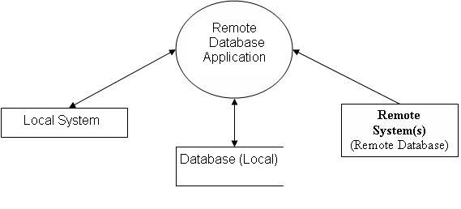

Once the application is started, it duplicates all the required remote databases into its local storage.

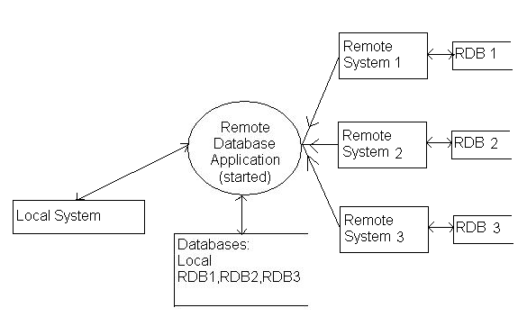

Copies of the remote databases are made into the local system by the application as soon as the application starts.

If any changes occur in databases at the remote sites, those changes are immediately reflected onto their respective copies at the local system.

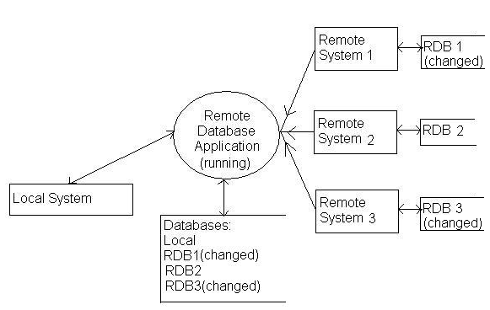

If any changes are made to the copy of remote database, those changes are not reflected onto the original remote database.

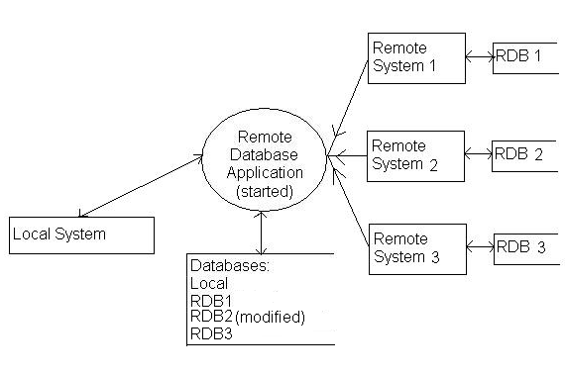

Thus the application Remote Database Access accesses remote databases but modifies them locally and it cannot update these changes onto the original remote databases.

The above Data Flow Diagrams illustrate the complete project.

Data Dictionary

Table Name: Employee

Name Null Type
EMPNO NOT NULL NUMBER (4)
ENAME VARCHAR2 (10)
JOB VARCHAR2 (9)
MGR NUMBER (4)
HIREDATE DATE
SAL NUMBER (7, 2)
COMM NUMBER (7, 2)
DEPT NUMBER (2)

Table Name: Department

NAME NULL TYPE
DEPTNO NOT NULL NUMBER (2)
DNAME VARCHAR2 (14)
LOC VARCHAR2(13)

E.R Diagram

HIREDATEEE

SALARY
JOB
MGR

ENAME

DEPT
EMPNO

EMPLOYEE

Belongs To

DEPARTMENT

LOC

DEPTNOO0O
DNAME

Implementation

Coding

In Remote Database Access implementation the various functions used and their functionalities are as follows.

Front-End Implementation

Creating an ODBC Database Program
For creating a Remote Database Access ODBC database program with Visual C++, there are a number of steps to complete:
(i) Register the database with the system.

(ii) Use AppWizard to create the basic database application.

(iii) Add code to the basic application to implement features not automatically supported by AppWizard.
The following sections will explain steps to create an application, which enables us to add, delete, update, sort, and view records in a table of the RDA database.

Registering the Database
Before creating a database application, one must register the database that they want to access as a data source that one can access through the ODBC driver. Follow these steps to accomplish this important task:
(i) Create a Database on the hard disk using SQL. The RDA database is created with Oracle. This database is used as the data source for the sample application.
(ii) From the Windows Start menu, click Settings and then Control Panel. When the Control Panel dialog appears, double-click the 32-Bit ODBC icon. The ODBC Data Source Administrator dialog box appears.
Connecting a data source to your application starts with the ODBC Data Source Administrator.
(iii) Click the Add button. The Create New Data Source dialog box appears. Select the Oracle ODBC Driver from the list of drivers and click Finish.

The Oracle Driver is now the ODBC driver that will be associated with the data source you create for the RDA application.

(iv) When the ODBC Oracle Setup dialog box appears, enter RDA in the Data Source Name text box and Remote Database Sample in the Description text box.

The Data Source Name is a way of identifying the specific data source created. The Description field enables you to include more specific information about the data source.

(v) Click the Select button. The Select Database file selector appears. Use the selector to locate and select the rda file.

(vi) Click OK to finalize the database selection and then, in the ODBC Oracle Setup dialog box, click OK to finalize the data-source creation process. Finally, click OK in the ODBC Data Source Administrator dialog box and close the Control Panel.

OnRecordAdd() Function
OnRecordAdd() starts with a call to the AddNew() member function of CEmployeeSet, the class derived from CRecordSet. This sets up a blank record for the user to fill in, but the new blank record doesn't appear on the screen until the view window's UpdateData() function is called. Before that happens, you have a few other things to tackle.
After the user has created a new record, the database will need to be updated. By setting a flag in this routine, the move routine will be able to determine whether the user is moving away from an ordinary database record or a newly added one. That's why m_bAdding is set to TRUE here.
Now, because the user is entering a new record, it should be possible to change the contents of the Employee ID field, which is currently set to read-only. To change the read-only status of the control, the program first obtains a pointer to the control with GetDlgItem() and then calls the control's SetReadOnly() member function to set the read-only attribute to FALSE.
Finally, the call to UpdateData() will display the new blank record.

OnMove() Function
Now that the user has a blank record on the screen, it's a simple matter to fill in the edit controls with the necessary data. To add the new record to the database, the user must move to a new record, an action that forces a call to the view window's OnMove() member function. Normally, OnMove() does nothing more than display the next record. Your override will save new records as well.
When OnMove() is called, the first thing the program does is check the Boolean variable m_bAdding to see whether the user is in the process of adding a new record. If m_bAdding is FALSE, the body of the if statement is skipped and the else clause is executed. In the else clause, the program calls the base class (CRecordView) version of OnMove(), which simply moves to the next record.
If m_bAdding is TRUE, the body of the if statement is executed. There, the program first resets the m_bAdding flag and then calls UpdateData() to transfer data out of the view window's controls and into the recordset class. A call to the recordset's CanUpdate() method determines whether it's okay to update the data source, after which a call to the recordset's Update() member function adds the new record to the data source.
To rebuild the recordset, the program must call the recordset's Requery() member function, and then a call to the view window's UpdateData() member function transfers new data to the window's controls. Finally, the program sets the Employee ID field back to read-only, with another call to GetDlgItem() and SetReadOnly().

OnRecordDelete() Function
Deleting a record is simple. OnRecordDelete() just calls the recordset's Delete() function. When the record is deleted, a call to the recordset's MoveNext() arranges for the record that follows to be displayed.
A problem might arise, though, when the deleted record was in the last position or when the deleted record was the only record in the recordset. A call to the recordset's IsEOF() function will determine whether the recordset was at the end. If the call to IsEOF() returns TRUE, the recordset needs to be repositioned on the last record. The recordset's MoveLast() function takes care of this task.
When all records have been deleted from the recordset, the record pointer will be at the beginning of the set. The program can test for this situation by calling the recordset's IsBOF() function. If this function returns TRUE, the program sets the current record's fields to NULL.
Finally, the last task is to update the view window's display with another call to UpdateData()

OnSortField() Function
All the sorting functions have the same structure. They close the recordset, set its m_strSort member variable, open it again, and then call UpdateData() to refresh the view with the values from the newly sorted recordset.
A CRecordset object (or any object of a class derived from CRecordset, such as this program's CEmployeeSet object) uses a special string, called m_strSort, to determine how the records should be sorted. When the recordset is being created, the object checks this string and sorts the records accordingly.

DoFilter() Function
Whenever the user selects a command from the Filter menu, the framework calls the appropriate member function, either OnFilterDept(), OnFilterID(), OnFilterName(), or OnFilterRate(). Each of these functions does nothing more than call the local member function DoFilter() with a string representing the field on which to filter.
DoFilter() displays the same dialog box, no matter which filter menu item was chosen, by creating an instance of the dialog box class and calling its DoModal() function.
If result doesn't equal IDOK, the user must have clicked Cancel: The entire if statement is skipped, and the DoFilter() function does nothing but return.Inside the if statement, the function first creates the string that will be used to filter the database. Just as one sets a string to sort the database, so, too, one sets a string to filter the database. In this case, the string is called m_strFilter. The string you use to filter the database must be in a form like this:
ColumnID = `ColumnValue'
The column ID was provided to DoFilter() as a CString parameter, and the value was provided by the user. If, for example, the user chooses to filter by department and types hardware in the filter value box, DoFilter() would set str to DeptID = `hardware'.
With the string constructed, the program is ready to filter the database. As with sorting, the recordset must first be closed; then DoFilter() sets the recordset's filter string and reopens the recordset.
The DoFilter() function handles the condition, where, a filter results in no records being selected, by obtaining the number of records in the new recordset and comparing them to zero. If the recordset is empty, the program displays a message box telling the user of the problem. Then the program closes the recordset, resets the filter string to an empty string, and reopens the recordset. This restores the recordset to include all the records in the Employees table.
Finally, whether the filter resulted in a subset of records or the recordset had to be restored, the program must redisplay the data--by calling UpdateData(), as always.
Back-End Implementation

To create a basic replication environment for Remote database Access that uses table snapshots to provide read-only access to a master site, complete the following steps:

- Create Global Database Link which must be created using “Net8 Easy Config”. The service name of Oracle and hostname or IP address of computer to which link is to be created must be known in advance. Before knowing the service name of Oracle that service must be started in that computer.

All users and PL/SQL or SQL subprograms in any database can use a global database link to access data and database objects in the corresponding remote systems.

- Let there be two systems namely “Dbase”(Local, Master Site) and “SCS1”(Remote)

- Now First create Global Database link using Net8Easy Config, here we connect Dbase to SCS1, where service name of Oracle in SCS1 is “CCC”.

The steps followed for creating Global Database Link using “Net8 Easy Config” are illustrated pictorially:

STEP1:
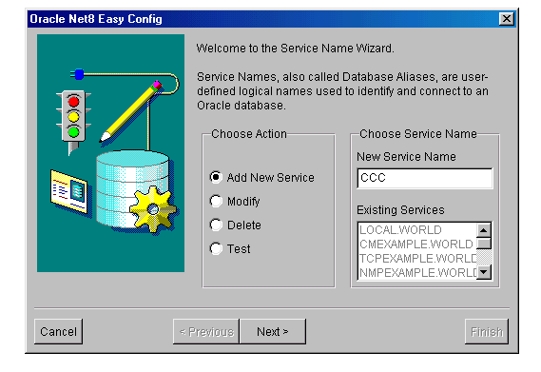

STEP 2:

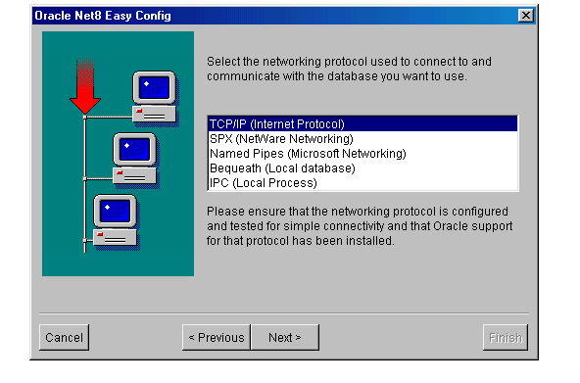
STEP 3:
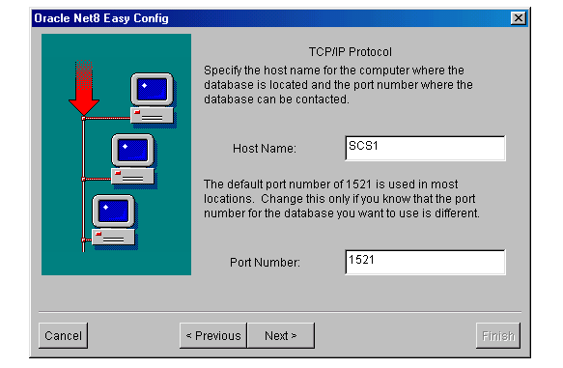

STEP 4:

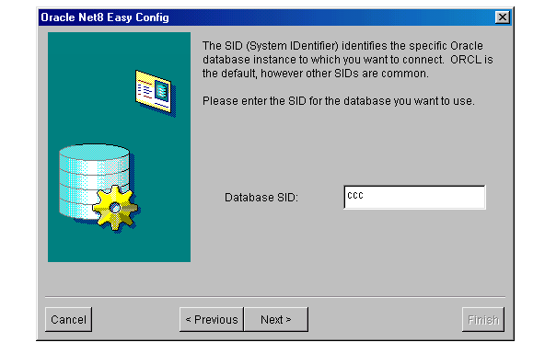

STEP 5:

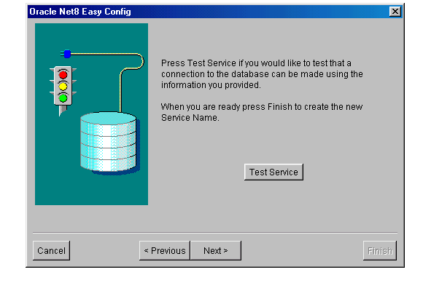

STEP 6:

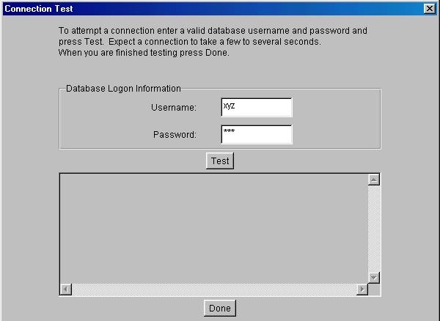

STEP 7:
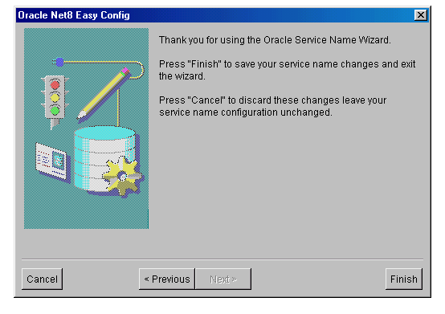

Thus, a Global Database Link is created.

The following is the procedure for implementing Remote Database Access application along with Pseudo code in respective systems (remote and Local systems).

Dbase System
- Conn system/manager (This user has Highest Privileges)
- Execute this statement in SQL prompt “Create user abc identified abc default tablespace users temporary tablespace temp;”
- Execute this statement in SQL prompt ”Grant dba to abc;”

SCS1 System
- Conn system/manager
- Execute this statement in SQL prompt ”create user xyz identified by xyz default tablespace users
- Execute this statement in SQL prompt “Grant dba to xyz”
- Now “conn xyz/xyz” .In this user we have to create tables which will be replicated in the ‘abc’ user of “Dbase” system
Dbase system
- Execute this statement in SQL prompt “conn abc/abc”
- Now create a database link “create database link CCC connect to xyz identified by xyz using ‘ccc’;” The place or the user in which we create database link there only we have to create Materialized view

SCS1 system
- We need to create log file only if we selected refresh option as ‘fast’
- Execute this statement in SQL prompt ”conn xyz/xyz”
- Execute this statement in SQL prompt ”create materialized view log on ‘RDA database’ with rowid/primary key”

Dbase system
- To check whether the link is established or not Execute this statement in SQL prompt” Select * from ‘RDA Database’@ccc;”
If this statement shows the table then link is correctly established
- Execute this statement in SQL prompt
Create materialized view pqrs
Refresh complete/fast
With primary key/rowed
Start with sysdate
Next sysdate+1/(24*60*60)
As select * from xyz.’RDA Database’@ccc;
- Execute this statement in SQL prompt “ select * from pqrs; to see the view
- If any changes occur at SCS1 ‘RDA Database’ then those will be reflected in materialized view of Dbase

TESTING

System Testing

Need For Testing:

In a software development project, errors can be injected at any stage during development. Mainly code development during the activity is likely to have some requirements errors and design errors in addition to errors introduced during the coding activity. Because code is frequently the only product that can be executed and whose actual behavior phase must be detected. Hence, testing performs a very critical role for quality assurance and for ensuring the reliability of software.

Testing Objectives:

Testing is a process of executing a program with the intent of finding an error; Software testing is one element that is referred to as Verification &Validation

Verification: “Are we building the product right?”
Validation :”Are we building the right product?”

- Testing is a process of executing a program with the intent of finding an error.
- A good test case is one that has a high probability of finding an as yet undiscovered error.
- A successful test is one that uncovers an as yet undiscovered error.
- Testing can not show the absence of defects, it can only show that absence of defects and it can only show that software defects are present

Test information Flow:

Information flows for testing the following pattern. Two classes of inputs are provided to test the process.

- A software configuration that includes software requirements specifications, a design speciation and source code.
- A test configuration that includes a test plan cases testing tools. Tests are conducted and all results are evaluated. That is that results are compared with expected results. When erroneous data are discovered an error in implied and debugging commences.

Software Testing Methods:

There are two types of testing techniques followed in designing and development of the information system. They are

- White –Box testing
- Black-Box testing

White Box Testing (Glass-box Testing):

White box testing is a test case design methods that uses the control structure of the procedural design to design to derive test cases. Using white box testing methods, the test cases should.

Guarantee that all independent paths within a module have been exercised at least once.

- Exercise all logical decision on their true and false sides.
- Execute all loops at their boundaries and within their operational bounds.
- Exercise internal data structures to ensure their validity.

Black Box Testing:

Black Box testing method focuses on the functional requirements of the software. This testing enables to derive sets of input conditions that will fully exercise all functional requirements of a program. Black Box testing attempts to find errors in the following categories.

- Incorrect or missing functions
- Interface errors
- Errors in data structures or external database access
- Performance errors
- Initialization and termination errors

White box testing is performed early in the testing process; Black Box testing is applied during later stages of testing. Black Box testing purposely disregarded control structure and focused on the information domain.

Software Testing Strategies:

Testing is a set of activities that can be planned in advanced and conducted systematically. A strategy for software testing must accommodation low-level tests that are necessary to verify that a small source code segment has been correctly implemented as well as high-level tests that validate major system functions against customer requirements.

There are four types of testing strategies

- Unit test
- Integration test
- Validation test
- System test

Unit Testing:

Unit testing focuses verification effort on the smallest unit of software design module. The unit test is always white box oriented. The tests that occur as part of unit testing are testing the module interface, examining the local data structures, testing the boundary conditions, execution all the independent paths and testing error-handling paths.

Integration Testing:

Integration testing is a systematic technique or construction the program structure while at the same time conducting tests to uncover errors associated with interfacing. Scope of testing summarizes the specific functional, performance, and internal design characteristics that are to be tested. It employs top-down testing and bottom-up testing methods for this case.

Validation Testing:

Validation testing demonstrates tractability to software requirements. Validation succeeds when the software functions in a manner that can be reasonably expected by the customer. The major elements of this process are alpha and beta testing along with the configuration review.

RESULTS

The output screens for the Remote Database Access application are as follows:

The application is executed at both remote and local systems.

At the local system, the RDA application is run.

The application prompts user for username and password (for security and authenticity purposes.)

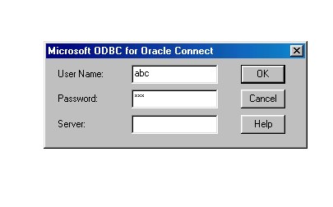

Then the user is prompted to enter a query.

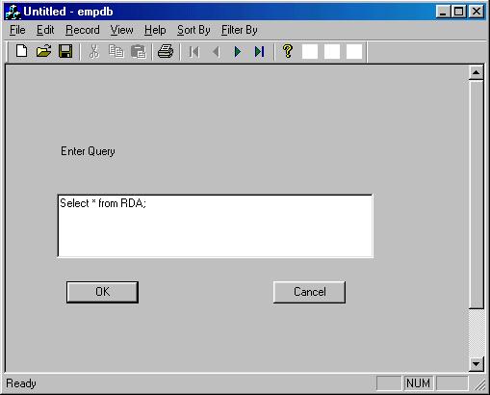

Then the application displays the records resulting from the query along with providing the user to move through the records from first to last.

MoveFirst() , MovePrevious() , MoveNext() and MoveLast() are the functions used to move through the records.

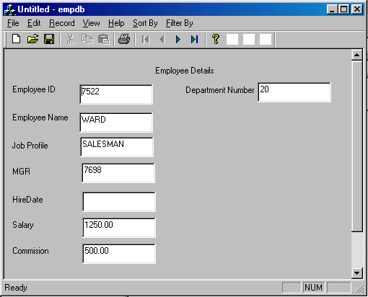

At the remote system, the application is run.

The application prompts user for username and password (for security and authenticity purposes.)

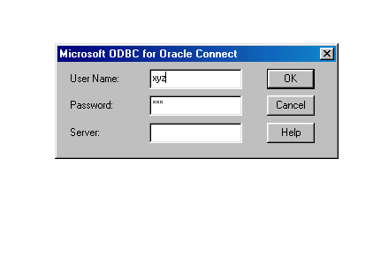

Then the user is prompted to enter a query.

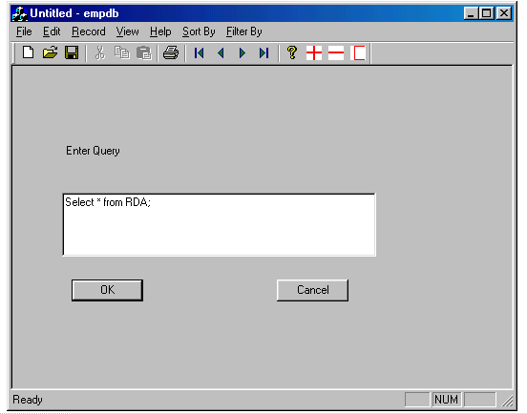

Then the application displays the records resulting from the query along with providing the user to move through the records from first to last.

MoveFirst() , MovePrevious() , MoveNext() and MoveLast() are the functions used to move through the records.

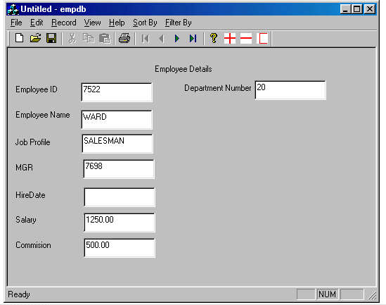

To see the next record, Next button is pressed.

The next record is displayed.

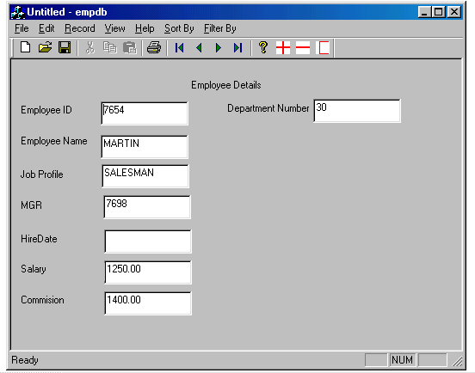
To enter new records into the table, first the values displayed in the fields for the present output have to be cleared.

For this, ‘ C ‘ button is pressed, which clears all the fields in the display.

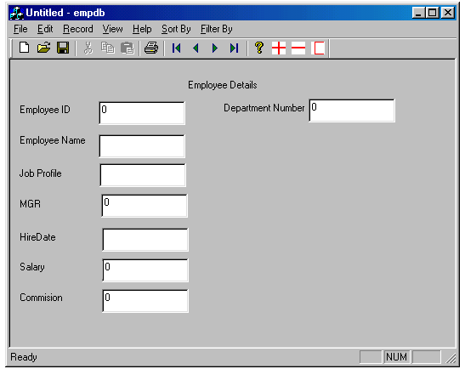

Then values are entered into the fields in the present display. This record can be added by pressing the ‘ + ‘ button.

The record gets added.

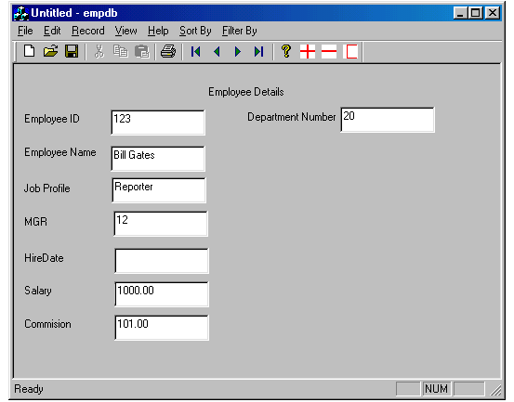

The RDA application also provides the user capability to remove any record. But, these changes will not be reflected onto the remote database (if the record modified was belonging to the copy of remote database in the local system).

Any record can be deleted by pressing the ‘ - ‘ button on the toolbar.

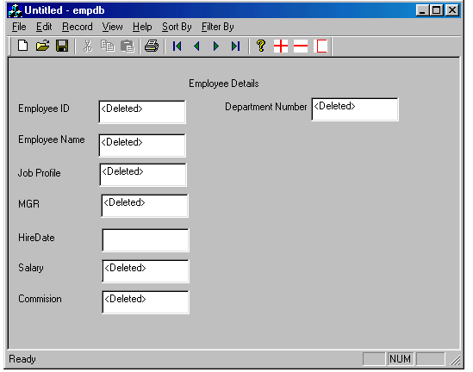

CONCLUSION

We have successfully completed the design, development and implementation work of the project with appropriate results on a real-time system without much of a trouble.

The designed application is easy to use, Simple and flexible. It can be felt that a lot of difference exists between theoretical concept and real life situation. However, the entire effort of the development of the project was enjoyable and whole experience was proved useful in real life.

In the Back-End we were successfully able to implement Basic Read Only Replication technique for Remote Database Access application

The project “Remote Database Access” has been able to retrieve remote databases residing in Windows(Oracle) .The retrieved databases are viewed(read-Only) by using front-end VC++ . The project is developed on Windows NT workstation with VC++ as front-end and Oracle 8 Enterprise Edition.

A Front-End VC++ process in the remote system has been able to retrieve its databases for CRUD (Create, Read, Update and Delete) operations. The CRUD operations done in this system was successful in reflecting its changes to the copy in the local system. Queries always return the data in the local system. Any updates on the copy of remote database will not be reflected in the original remote database.

Future Enhancement

The application Remote Database Access can be enhanced in future using advanced concept of Replication for more flexibility and efficiency. The concept of Advanced Replication is supported by Oracle Enterprise edition.

Advanced Replication
The Oracle advanced replication features extend the capabilities of basic read-only replication by allowing applications to update table replicas throughout a replicated database system. With advanced replication, data replicas anywhere in the system can provide both read and update access to a table's data. Participating Oracle database servers automatically work to converge the data of all table replicas, and ensure global transaction consistency and data integrity. Figure illustrates advanced replication.

Figure - Advanced Replication

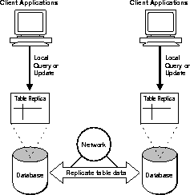

Oracle Server can support the requirements of advanced replication environments using several configurations

Uses for Advanced Replication
Advanced data replication is useful for many types of application systems with special requirements.

Disconnected Environments
Advanced replication is useful for the deployment of transaction processing applications that operate using disconnected components. For example, consider the typical sales force automation system for a life insurance company. Each salesperson must visit customers regularly with a laptop computer and record orders in a personal database while disconnected from the corporate computer network and centralized database system. Upon returning to the office, each salesperson must forward all orders to a centralized, corporate database.

Failover Site
Advanced replication can be useful to protect the availability of a mission critical database. For example, an advanced replication system can replicate an entire database to establish a failover site should the primary site become unavailable due to system or network outages. In contrast with Oracle's standby database feature, such a failover site can also serve as a fully functional database to support application access when the primary site is concurrently operational.

Distributing Application Loads
Advanced replication is useful for transaction processing applications that require multiple points of access to database information for the purposes of distributing a heavy application load, ensuring continuous availability, or providing more localized data access. Applications that have such requirements commonly include customer service oriented applications.

Figure: Advanced Replication System Supporting Multiple Points of
Update Access
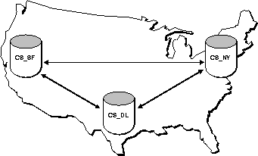

Information Transport
Advanced replication can be useful as an information transport mechanism. For example, an advanced replication system can periodically off-load data from an update-intensive operational database to a data warehouse or data mart.

Advanced Replication Configurations
Oracle supports the requirements of advanced replication environments using multimaster replication as well as snapshot sites.

Multimaster Replication
Oracle's multimaster replication allows multiple sites, acting as equal peers, to manage groups of replicated database objects. Applications can update any replicated table at any site in a multimaster configuration. Figure illustrates a multimaster advanced replication system.

Figure - Multimaster Replication System
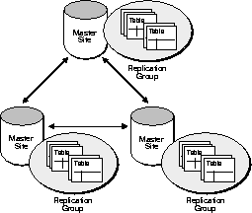

Snapshot Sites and Updatable Snapshots
Master sites in an advanced replication system can consolidate information that applications update at remote snapshot sites. Oracle's advanced replication facility allows applications to insert, update, and delete table rows through updatable snapshots. Figure illustrates an advanced replication environment with updatable snapshots.

Figure - Advanced Replication System with Updatable Snapshots

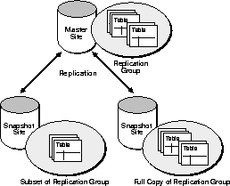
Updatable snapshots have the following properties.
- Updatable snapshots are always simple, fast-refreshable table snapshots.
- Oracle propagates the changes made through an updatable snapshot to the snapshot's remote master table. If necessary, the updates then cascade to all other master sites.
- Oracle refreshes an updatable snapshot as part of a refresh group identical to read-only snapshots.
- Updatable snapshots have the same underlying objects, such as base table, indexes, and views, as read-only snapshots. Additionally, Oracle creates the table USLOG$_snapshotname to support updatable snapshots.
Hybrid Configurations
Multimaster replication and updatable snapshots can be combined in hybrid or "mixed" configurations to meet different application requirements. Mixed configurations can have any number of master sites and multiple snapshot sites for each master.
For example, as shown in Figure, n-way replication between two masters can support full-table replication between the databases that support two geographic regions. Snapshots can be defined on the masters to replicate full tables or table subsets to sites within each region.

Figure Hybrid Configuration
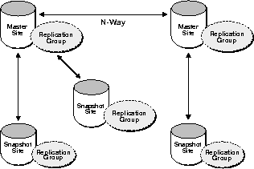
Key differences between updatable snapshots and replicated masters include the following:
- Replicated masters must contain data for the full table being replicated, whereas snapshots can replicate subsets of master table data.
- Multimaster replication allows you to replicate changes for each transaction as the changes occur. Snapshot refreshes are set oriented, propagating changes from multiple transactions in a more efficient, batch-oriented operation, but at less frequent intervals.
- If conflicts occur from changes made to multiple copies of the same data, master sites detect and resolve the conflicts

BIBLIOGRAPHY

References:

- Programming Microsoft Visual C++ 5th Edition, David J.Kruglinski, George Shepherd, Scot Wingo

- Oracle8 Replication Release 8.0 from Oracle Documentation

- Oracle8 Distributed Database, Systems Release 8.0 Oracle Documentation

- Oracle8 SQL Reference, Release 8.0 Oracle Documentation

- Concepts of DBMS, C.J.Date

- DBMS Korth and Sudharshan

- Software Engineering, Pressman

- MSDN Help, Microsoft Corporation

Help From Websites:
http://www.oracle.com
http://www.orafaq.com
http://www.databasejournal.com
http://www.codeguru.com

